Table of Contents
Terminating Primary Job/Secondary Jobs 1
Terminating a Job that contains the Hire row and indicated as Primary 1
Job Data 1
Terminating a Secondary Job that does not contain a Hire row 4
Job Data 4

Terminating Primary Job/Secondary Jobs
This document provides instructions on how to terminate a Job that contains a HIRE row, a Job Indicator of Primary, and the employee has another job(s) at the same college which does not contain a HIRE row that needs to remain active.
NOTE: Additional Jobs that contain a HIRE row will not be terminated when the process below is followed.

Terminating a Job that contains the Hire row and indicated as Primary
If the assignment you wish to terminate is designated as Primary and also contains the HIRE row, it must be changed to be the secondary job prior to terminating the record. When the record is terminated, it will terminate other active jobs that do not have a HIRE row. This job will need to be re-activated.

Job Data
Navigation>Workforce Administration>Job Information>Job Data>Work Location
- Retrieve the current Primary row.
- ADD a row
- Enter the data below
- Effective Date- Enter effective date of the termination
- Job Indicator – Change to Secondary (You may get several messages. Click OK)
- Action – Choose Termination
- Reason – Choose Reason from dropdown.
SAVE

NOTE: When you save the record you will get several messages. These are just warnings. Click OK

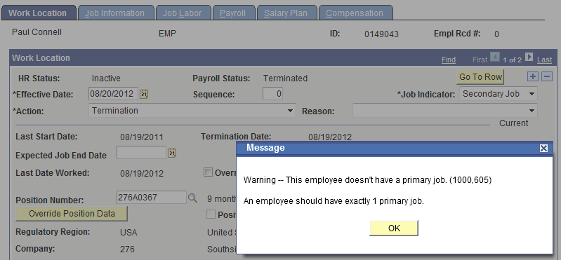
a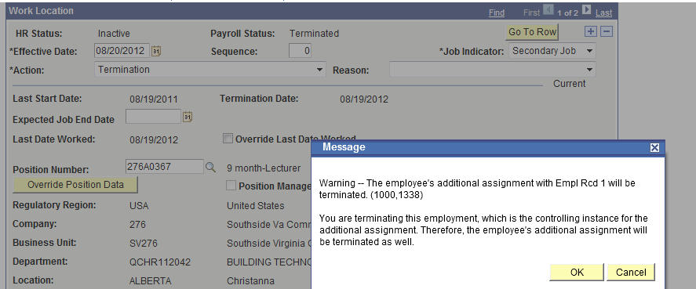
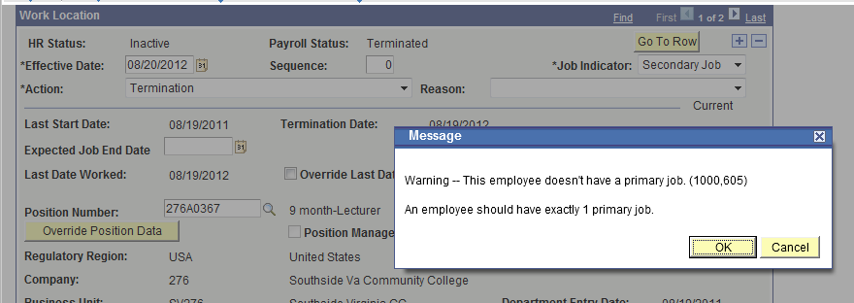
Now you are ready to change the previous Secondary job to be Primary.
Go to the job that was indicated as Secondary.
NOTE: The Secondary job has been terminated and a termination row with the same effective date as the terminated record has been inserted.
To re-activate the job that has been terminated and change the Job Indicator from Secondary to Primary follow the steps below:
- IN CORRECTION (Do not add a row)
- Enter the data below
- Effective Date – Leave as default
- Action - Change Termination to Data Change. Notice the record becomes Active.
- Reason – Choose Job Indicator Change
- Job Indicator - Change to Primary.
SAVE

NOTE: The status of this record will automatically change from Terminated to Active.
The Action/Reason of Data Change/Job Indicator Change will not send a transaction to PMIS.

Terminating a Secondary Job that does not contain a Hire row
Terminating a Secondary Job that does not contain a Hire row is outlined below. Terminating a Secondary Job does not affect a job with a Hire row.
Navigation>Workforce Administration>Job Information>Job Data>Work Location

Job Data
- Make sure the Job Indicator of the record you with to terminate indicates Secondary.
- ADD A ROW
- Complete the fields below
- Effective Date – Enter date of termination
- Action – Enter Termination
- Reason – Choose from dropdown
SAVE
