Good morning,

As we’ve previously shared, the tool that supported interfacing postings directly into the Commonwealth site was outdated and no longer supported by PeopleAdmin. Last fall, we launched a project with PA to implement an enhanced solution that will enable better integration between the various versions of PA in place with colleges and universities. The improvement is designed to provide a more efficient single source for Commonwealth job postings.

Although the effort has taken longer than expected, the new panoramic site is now in production. The updated site will reflect job postings from all versions of PeopleAdmin being used by Higher Ed Institutions in real time, which eliminates the need to duplicate a posting in both the Higher Ed PA site and RMS. We’ve also added direct links to all Higher Education Institutions, including those on other platforms, through the same page to enhance the applicant experience. Applicants may still navigate to postings through Jobs.Virginia.gov and will have multiple ways to review available opportunities.

We hope this change resolves the challenges you’ve noted with postings in RMS and supports the ongoing efforts to attract top talent to Commonwealth employment.

The new navigations steps are noted below for your reference.

- Go to http://jobs.virginia.gov/ . Click on Explore Job Opportunities.

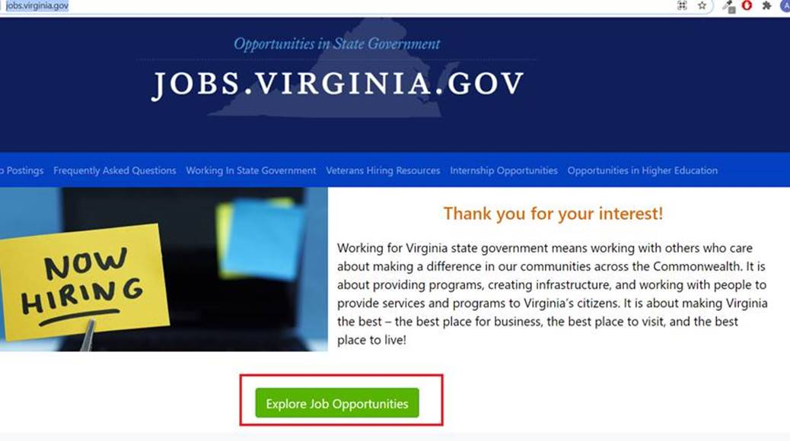

- You will be taken to the PeopleAdmin site link: https://virginiajobs.peopleadmin.com/ . In the below site click on Higher Education Jobs.
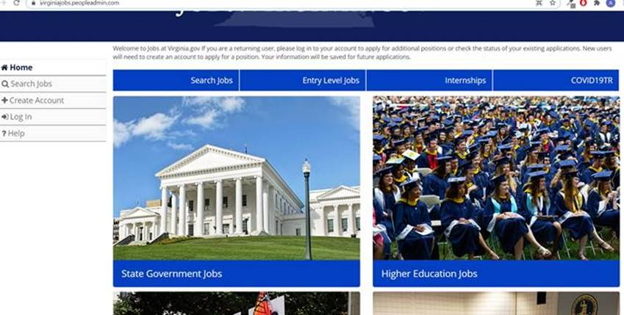

- You will be directed to the panoramic site for Higher Education jobs. Shown below.
Marked in Red - All Higher Education Jobs. Directed to http://jobs.virginia.gov/Mobile/higherEducationList.html
Marked in Yellow – Will direct you to the individual institutions
Marked in Green – Search for all jobs in institutions under PeopleAdmin

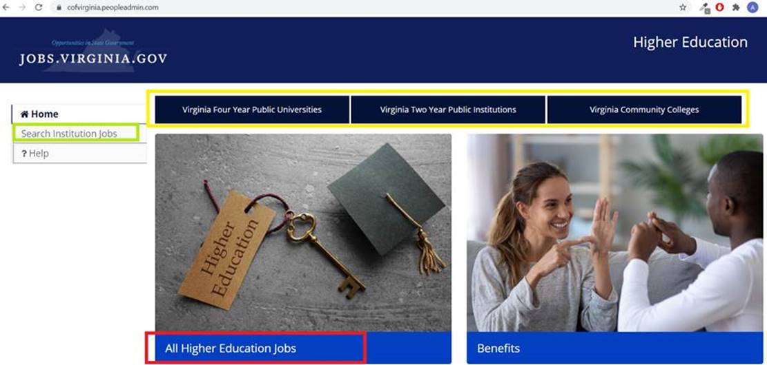

Please let me know if you have any questions or concerns with these changes.

Thanks,
Natalie

Natalie Brannon, SHRM-SCP, SPHR
Talent and Policy Services Director
Human Resources Consulting Services
Department of Human Resource Management

Office: 804.225.2731; Cell: 804.837.7134
Fax: 804.371.7401
natalie.brannon@dhrm.virginia.gov

