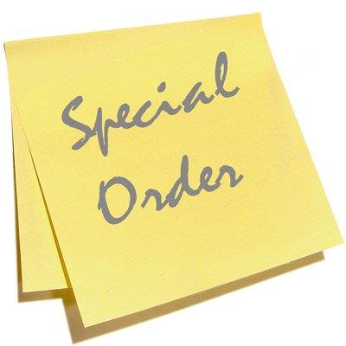 | May 2021  VDCCustomerCare@dgs.virginia.gov

SPECIAL PURCHASE FOR VCCS

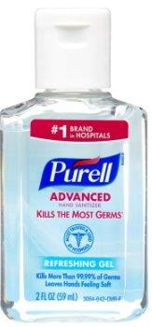 | 930657 SANITIZER, hand, gel, purell | 24/2 oz. per case | $ 52.64

MARK YOUR CALENDAR FOR THESE STATE HOLIDAY CLOSINGS
May 31st Memorial Day
June 18th Juneteenth Day
July 5th Independence Day

View our catalog https://shopvdc.dgs.virginia.gov
Visit our website http://vdc.dgs.virginia.gov
Follow us on Twitter @VDCvirginia

