How to Access the New VCCS Intranet
- Open a web browser
- Enter http://intranet.vccs.edu in the address bar and press Enter
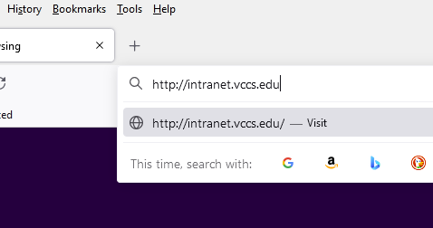
- Enter your complete myVCCS ID (e.g. jsmith0001@email.vccs.edu) in the username field and Click Next
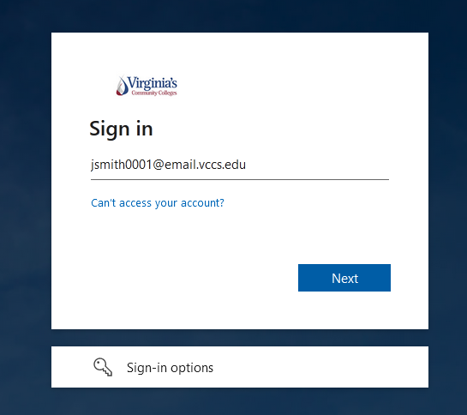

- Enter your password and Click Sign In
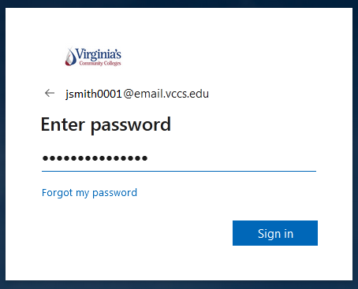
- At the Stay signed in? prompt – click Yes
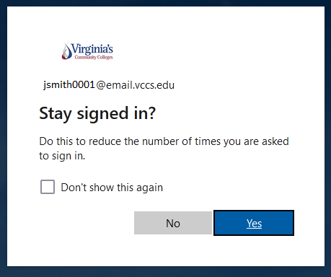
- You are now redirected to the New VCCS Intranet Homepage (https://onvccs.sharepoint.com/)
