HR Staff have three potential activities for New Year Leave Processing:

Manage Excess Carryover Leave for eligible employees

Manage Leave Accruals for employees hired between 12/25/21 & 1/10/22

Reload STD and Parental Leave Balances

Steps to accomplish these tasks are provided below

--------Perform these steps after January 13th and prior to January 20th --------

Manually key excess leave for Classified Employees with Leave Carryover Exception Forms:
Performing these steps now will provide your employees with the most up to date and accurate leave balances. However, you can perform these steps later and the retro-trigger process will add the balances to begin on 1/10 and will reprocess any Annual leave requests impacted by the addition of the Excess Leave.
*Note, review the Excess Carryover Leave Query(s) produced by the SSC and posted to your College File Exchange folder. This document will provide you with an accurate amount of Excess Leave existing for the employee as of the end of 2021.

- Admin/Faculty Old Annual Leave Plan prior to 2007 (Plan 11) will automatically receive excess leave balances. No manual processes are required.

- Admin/Faculty Old Annual Leave Plan after 2007 (Plan 36)

Perform the following steps to enter Excess Leave
- Go to the Adjust Absence page
- Key in the employee’s ID
- Key in the proper EX1 calendar name – remember, calendar names include the employee pay group number. For example, a 070 pay group employee will be in the: (college letter) 070210110EX1 calendar.
- Click Search
- On the Adjust Absence Balance page, select Plan 48ANLPROFACA
- Key the hours of Excess Leave
- Click Save

- Classified Staff (Plan 29) employees must submit proper documentation to carry over greater amounts than policy allows

Perform the following steps to enter Excess Leave
- Go to the Adjust Absence page
- Key in the employee’s ID
- Key in the proper EX1 calendar name – remember, calendar names include the employee pay group number. For example, a 074 pay group employee will be in the: (college letter) 074210110EX1 calendar.
- Click Search
- On the Adjust Absence Balance page, select Plan 61ANLCLSLV
- Key the hours of Excess Leave
- Click Save
When you place the leave into these excess leave plans, it is managed according to state policy:
- When the employee selects to use their annual leave, HRMS will automatically deduct from the excess leave plans until these balances are exhausted.
- On July 9th, any excess leave balances remaining in these plans are automatically removed.

Actions required for New Hires/Transfers between 12/25/21 & 1/10/22 who receive Leave Benefits
During the time period 12/25 – 1/10, a minor flaw in the Calendar Processing Logic causes the employee to accrue Annual Leave incorrectly.
- An employee hired 12/25 or 1/10 will receive an extra annual leave accrual
- An employee hired 12/26 – 1/9 should not receive an accrual, but may receive an annual leave accrual.

To correct this issue, perform the following steps:

Go to Query Viewer and run this query: VX_AM_LST_NEW_HIRES

Key the AM Begin Date 12/25/21 & AM End Date 1/10/22
Example (using previous year’s dates) shown below
Key fields on the report are numbered and their purpose is described below:
- Identify the employees with Absence Management. Only these employees are affected by this issue. If the report produces a long list of hires, you may choose to export the report to EXCEL and sort or filter the report to identify only these employees
- EMPL CLASS will help you determine the employee’s Annual Leave Plan. For example, Classified employees will have Plan 29 Classified Staff Annual Leave. 12-month Faculty employees will have Plan 36 for New Faculty Annual Leave or Plan 11 for Old Faculty Annual Leave.
- If the employee is in a Faculty Empl Class and the Service date is prior to 1/1/2007. Further research is required to determine if the employee has the Old Faculty Annual Leave Plan (11) or New Faculty Annual Leave Plan (36). Go to the employee’s Leave Balances page to review the employee’s leave balances and determine the answer.
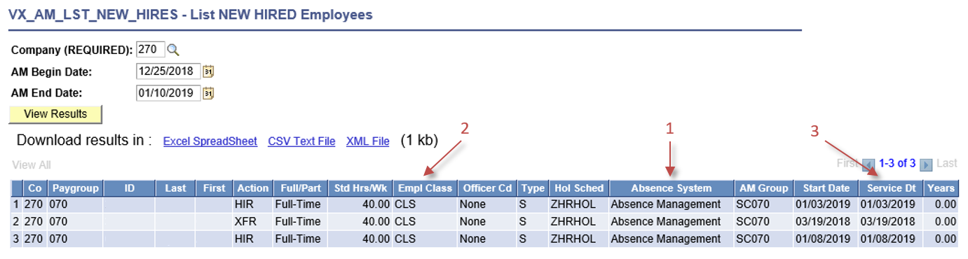

Using the query shown above identify the following pieces of information:
- New Hires from 12/25/21 – 1/10/22 who will be processed by Absence Management
- Annual Leave Plan for the employee

Navigate to the Assign Entitlements and Takes page

Enter the EMPLID

Click Search

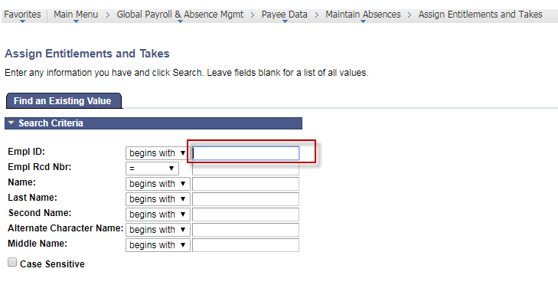

Add a No Accruals entry for the employee for 1/10/2022

Click Save
Example shown below
Be certain you key the date 1/10/2022. A clerical error in this field will cause unwanted results.
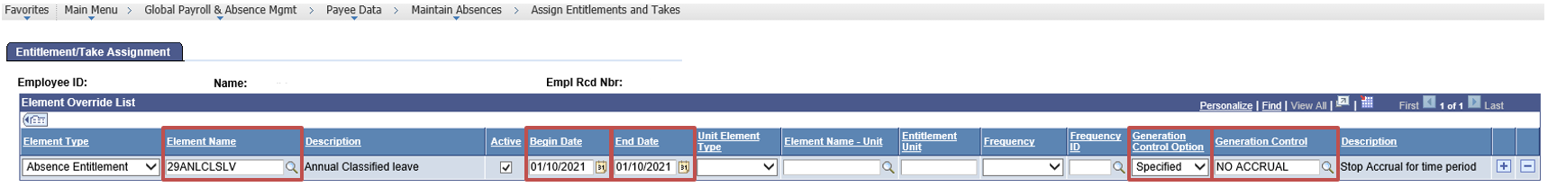

Once the 1/10 New Year Calendars are complete, review the employee’s leave balances and confirm the process worked correctly

Reload Short Term Disability and Parental Leave Balances

All STD Leave and Parental Leave balances will be eliminated as of 1/9/2022. Perform the following two processes to move the STD and Parental Leave balances into the New Year starting on 1/9/2022.
- Locate employees that currently have STD Leave and Parental Leave Balances
- Manually reload the STD and Parental Leave balances so they continue to be available

To locate employees with Short Term Disability:
- Run the following query to Excel: VX_AM_CALENDAR_GR
See the screen image below
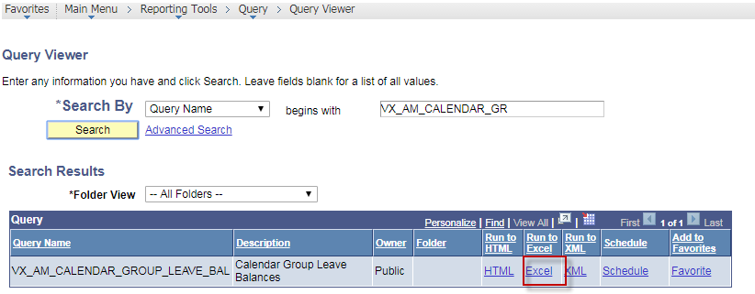
- Key your college’s 1/9 EN1 Calendar name in the prompt (note, this will not be available to run until Thursday, Jan. 13th after 3:00 p.m., after the 1/9 calendars are finalized)
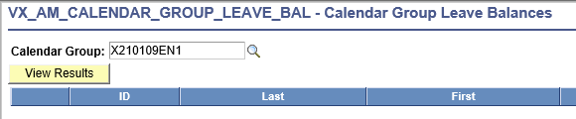
- In Excel, Click cell D2 to select the LEAVE column.
- Click Data in the Menu bar
- Click the Z-to-A sort feature or use a filter to find all STD and Parental Leave Balances
See the Screen Image below
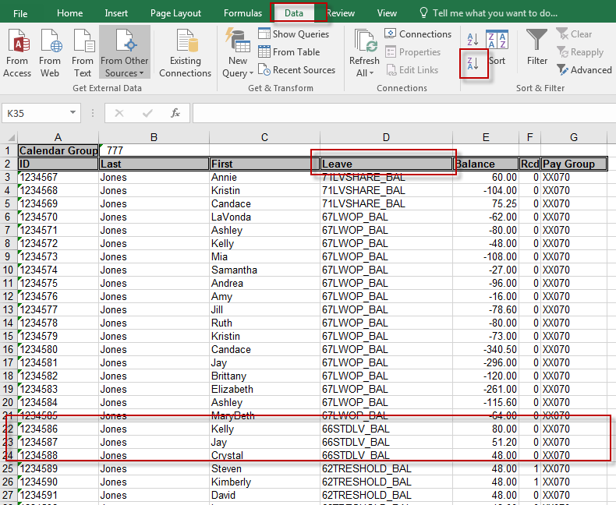
To reload Short Term Disability balances, use the Adjust Absence Page
- Go to the Adjust Absence page
- Key in the employee’s ID
- Key in the 1/9 EC1 calendar name – remember, calendar names include the employee pay group number. For example, a 074 pay group employee will be in the 074210110EC1 calendar.
- Click Search
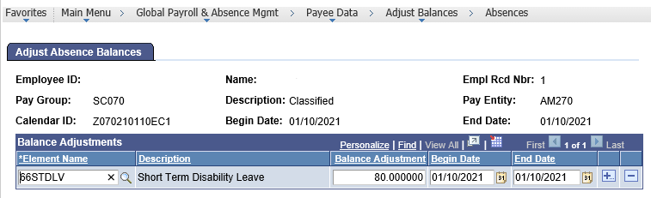
- On the Adjust Absence Balance page, select Plan 66STDLV or 73PARENT
- Key the hours of STD or Parental Leave
- Click Save.

Also to note, Executive Staff moving to 15 years of service (Leave Plans 04, 05, 08, and 09)

HRMS will automatically provide the proper new leave plan, but it does not move the balance from the old leave plan.

Overview of Leave Balance Adjustments in the 12/25 – 1/10 time frame
The above steps should resolve any leave issues for 12/25 – 1/10. However the following information is provided if other leave adjustments are needed.
Use the Adjust Absences page to make any necessary adjustments. The following information will help you recognize the proper calendar to use to associate the adjustment:
Leave Type | Adjustment Calendar | Leave Plans
Semi-Monthly Accrued Leave Plans | Adjust leave balances using the 1/10 EC1 Calendar | 11: Old Faculty Annual Leave Plan  29: Classified Staff Annual Leave Plan  31: Traditional Sick Leave  36: New Faculty Annual Leave Plan
Excess Leave Plans | Adjust leave balances using the 1/10 EX1 Calendar | 37: Excess Leave for Old Annual Leave Plan 11 with VSDP Sick  28: Excess Leave for Old Annual Leave Plan 11 with Traditional Sick  61: Excess Leave for Classified Staff  64: Excess Leave for Executive Annual Leave Plan 05  33: Excess Leave for Executive Annual Leave Plan 08  34: Excess Leave for Executive Annual Leave Plan 04  35: Excess Leave for Executive Annual Leave Plan 09  48: Excess Leave for New Admin/Faculty Leave Plan 36
Annual Accrued Leaves | Adjust leave balances using the 1/10 EC1 Calendar | 01: 9-Month Faculty Sick Leave  03: Volunteer Services  06: VSDP Sick  07: VSDP Family  04: Executive Leave  05: Executive Leave  08: Executive Leave  09: Executive Leave
Special Purpose Leave Plans | Adjust leave balances using the 1/9 EN1 Calendar. | 50: Bonus  51: Comp Leave  52: Military Leave  54: Civil and Work Related Leave  55: Overtime Leave  56: Recognition & Retention  57: Organ Donor Leave  60: Disability Credits  63: Education Leave  68: Workers Comp Leave  69: Other Leave

