Run the Leave Liability Query prior to the 6/24 Leave Liability Report date
The query will provide you with employee information. If you find any incorrect information, you can correct it now and improve the accuracy of your Leave Liability Report.

The output from this query is identical to the output on the Leave Liability Report. The organization is slightly different, and the data is not summarized. However, unlike the Leave Liability Report, which is in PDF format, this query can be produced in Excel format, which enables you to perform calculations, data analysis and validation. Use the query now to validate the employee data that will be used for Leave Liability Report calculations. Corrections made to the employee data prior to the 6/24 calendar processing period will increase the accuracy of your Leave Liability Report.
You can run the Leave Liability Query at any time throughout the year. Run the process using any EN1 calendar group to review the basic Employee profile information used by the Leave Liability Report.
- Navigate to the Query Viewer page (Reporting Tools > Query > Query Viewer)

- Search by Query Name: VX_HR_LEAVE_LIAB_QRY. Select Search.

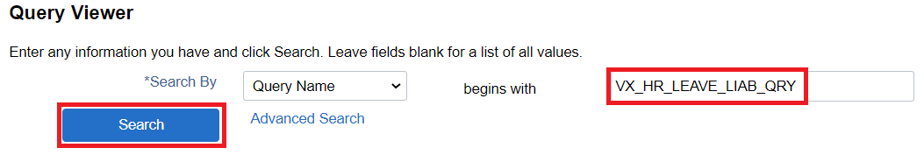

- Select Schedule to schedule the query to run

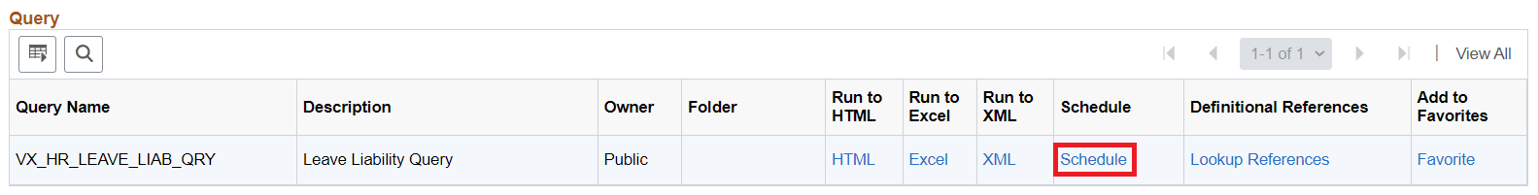

- If this the first-time running report:

● On Add a New Value tab, enter a Run Control ID: leave
● Select Add
● Select leave
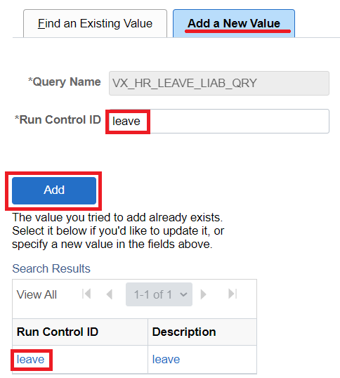
If previously run report:
● On Find an Existing Value tab, leave defaults
● Select Search
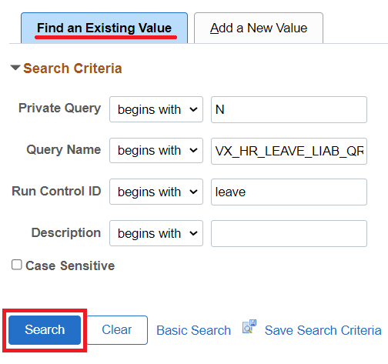

- Enter Calendar Group, then select OK

● Use a current calendar group so that you have a current employee list and current employee data. Any calendar can be selected for this step. Key in ALL CAPS (the alpha characters must be in CAPS).
Format: Agency Letter/YY/MM/DD/EN1
● If you have employees in the 071 pay group, you will need to run a separate report with that calendar group to view those employees.
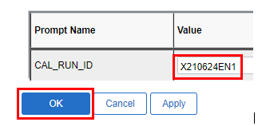
- Set the Process Scheduler Request information:
- Server Name: PSUNX
- Type: Web
- Format: XLS
- Select OK

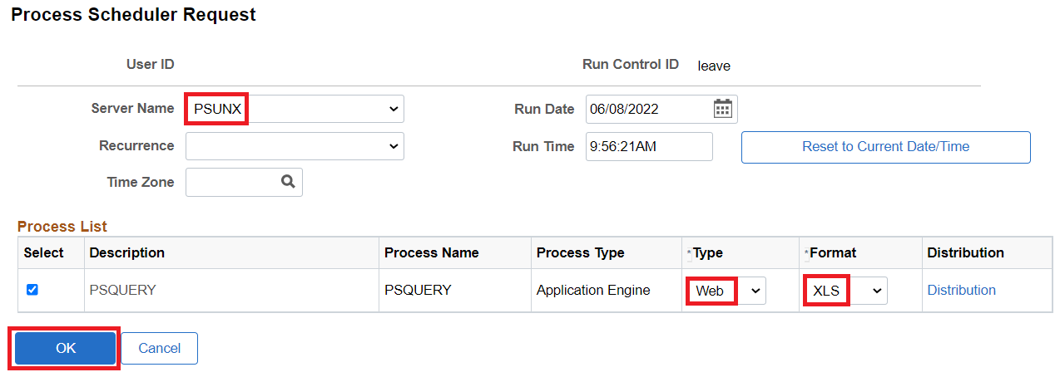

- Navigate to the Process Monitor page (People Tools > Process Scheduler > Process Monitor)

- Select Refresh, until the Run Status has completed to Success and the Distribution Status is Posted, which indicates the report is complete. The scheduled query process may take several minutes for the Run Status to result to Success and Posted.
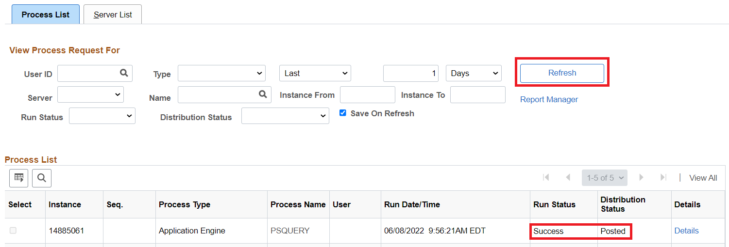

Select the Details hyperlink
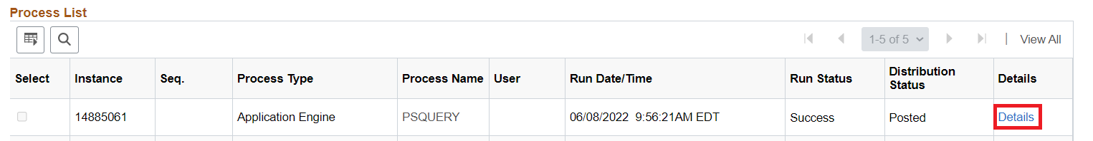

- On the Process Details page, select View Log/Trace
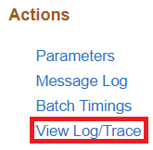

- On the View Log/Trace page, select the XLSX file to download it

- Open the Excel file

12. Review the employee data
● The columns shown below (first 18 columns) contain the employee data that is used by the Leave Liability Report. If you find incorrect information, go to HRMS and make the necessary modifications.
● Any improvements made to the accuracy of this data before 6/24 will be reflected on the Leave Liability Report.
● Refer to the document entitled: Leave Liability Report – Column Definitions to determine the location of the data in HRMS that requires modifications.
● These columns show the leave balances that are taken from the calendar you designated when you ran the query.
● Refer to the document reference above for a complete list of the leave Entitlements contained in each of these columns.

