VCCS Additional Pay Data Entry
Navigation:
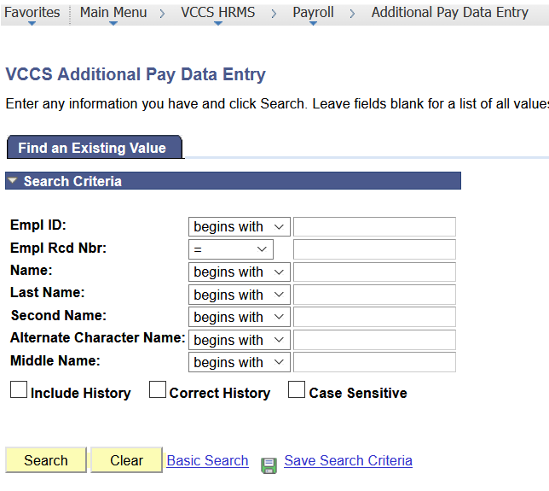
Enter the EMPL ID number or search by Last Name and select the employee.
For new hires with no payment history, the page will look like this:
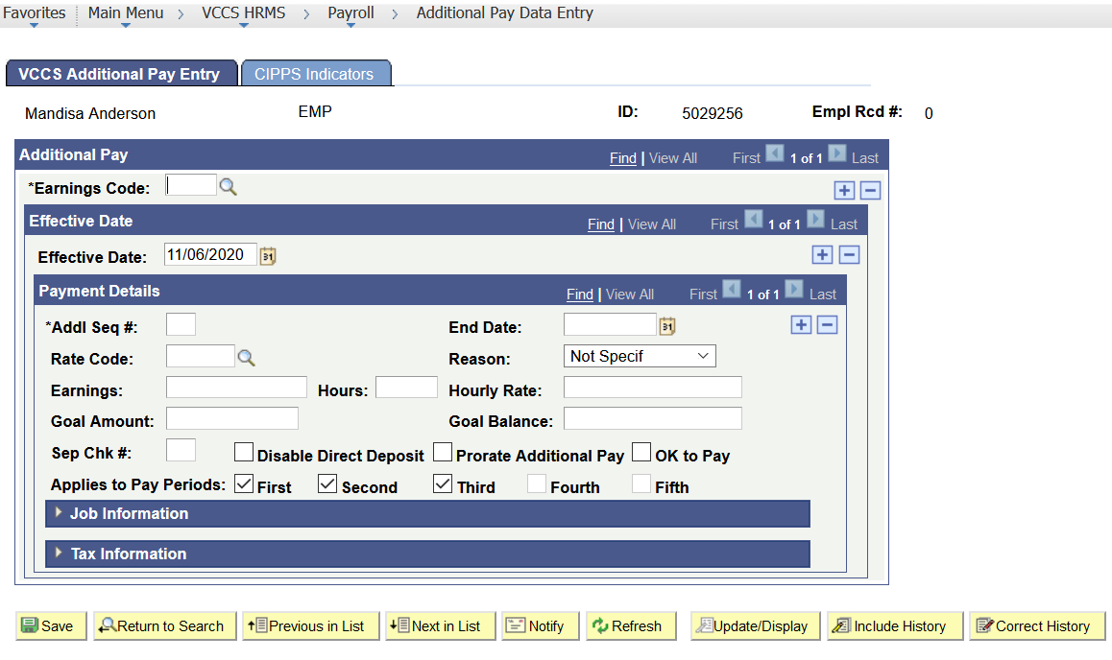

Complete the following on the VCCS Additional Pay Entry tab:
Earnings Code:
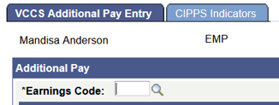
Enter the appropriate Earnings Code or use drop down menu to select 016 Adjunct Faculty or 018 for WDS Faculty.
Effective Date:
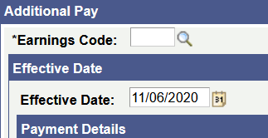
The default value will be the current date. Always change to the class start date to ensure the payment will process for the current pay period.
Payment Details:
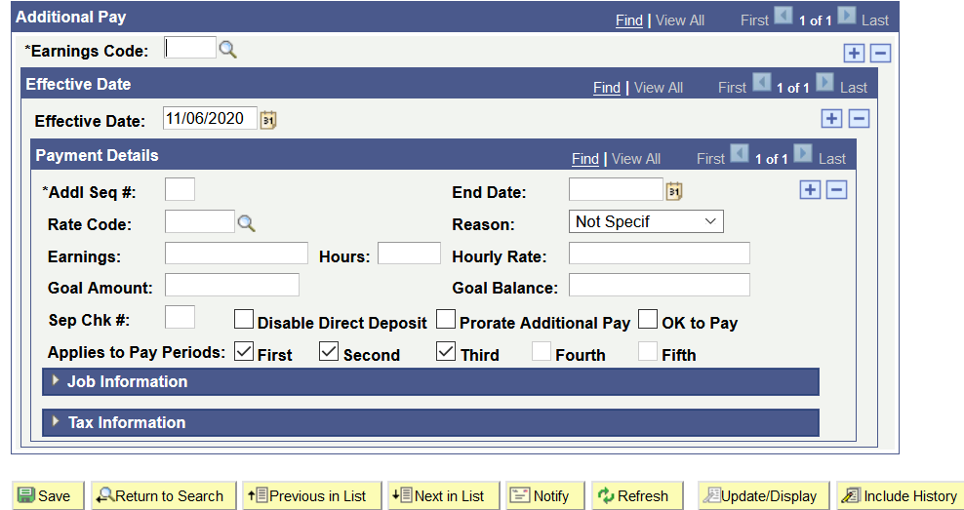
Addl Seq# - Required Field – enter 1 for all new contracts. If additional classes start on the same date and entering the amounts for each one is desired, additional sequences (2, 3, etc.) may be added.
End Date: not required, not used by the VCCS.
Rate Code: not required, not used by the VCCS.
Reason: default is Not Specif, not used by the VCCS.
Earnings: enter the amount of each payment. Example: for an $8000 contract for a 16-week class paid in 8 biweekly payments over the course of the semester, the “Earnings” will be $1000.
Hours: not required, not used at PVCC
Hourly Rate: not required, not used by the VCCS.
Goal Amount: contract total. In the example above, the goal amount is $8000.
Goal Balance: leave blank. This field will populate when the first payment is made and will increase as payments are added until the Goal Balance equals the Goal Amount. Payments for the contract will then stop.
- Cardinal will maintain the goal balance. Once goal amount equals the goal balance the system will stop paying.
Sep chk#: not required, not used by the VCCS.
Disable Direct Deposit: not required, not used by the VCCS.
Prorate Additional Pay: not required, not used by the VCCS.
Ok to Pay: must be checked or payment will not process
Applies to Pay Periods: if the employee is set up in the correct frequency, there will be check marks in First, Second and Third. This corresponds to the monthly pay periods. This does not indicate the number of payments that will be made. Checking all three boxes ensures that payments will be made based on the employee’s pay frequency.
Tax Information: not required, not used by the VCCS.
Complete the following on the CIPPS Indicators Tab:
All fields will populate from the data entered on the Additional Pay tab except:
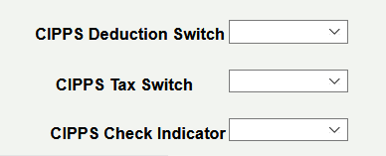

VCCS uses 0, 5, 3. The available options will appear when you click the arrow at the far right of the box.
Review the entry. Click Save at the bottom left corner of the page.

